**List of Practical**

**Course: B.Tech CS & IT Semester: VI**

**Subject: Web Technology Lab Subject Code: [PBC-602, PIT-602]**

1. Create a web page to print the following table:

**List of Course-wise Subjects**

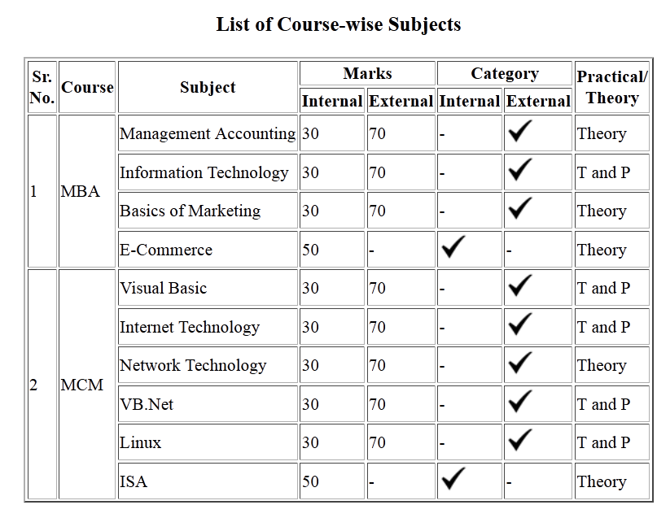

2. Using table related tags align the images with hyperlinks.



3. Create a web page with the following using HTML:

1. To embed an image map in a web page
2. To fix the hot spots
3. Show all the related information when the hot spots are clicked.

4. Create a web page having frames as follows:

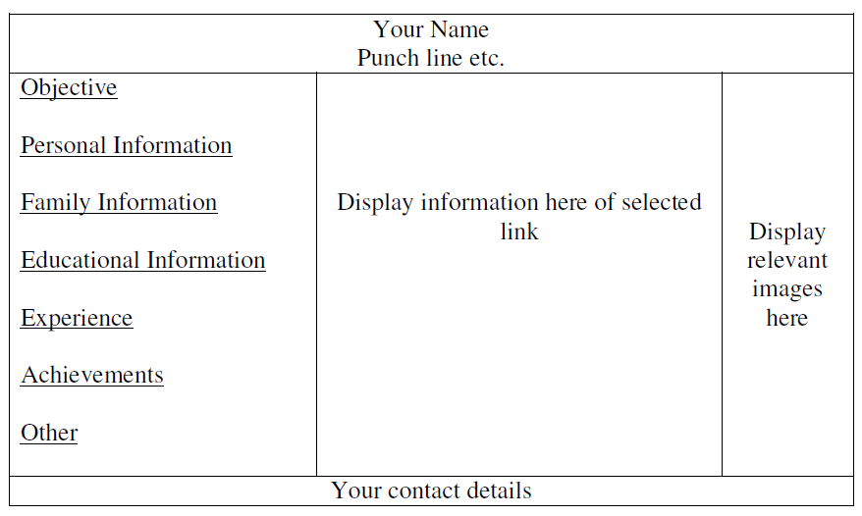

The frame which includes Objective, Personal Information ect. are the hyperlinks. Display the relevant information in the next frame on selecting the link. The colour scheme of hyper links should be as follows:

default – green

active – red

visited – blue

The information should be well formatted. Follow the instructions mentioned in the above format.

5. Demonstrate the use of <IFRAME> tag using suitable example.